PYTHON ACTIVITY-BASED LEARNING
10 Complete Case Study Solutions

Selected case studies
- 1. Progressive Electricity Billing
- 2. Employee Payroll and Deduction Analysis
- 3. Retail Billing with Discount Rules
- 4. Examination Result and Grace-Mark Validation
- 5. ATM Transaction Sequence Simulation
- 6. Warehouse Inventory Reconciliation
- 7. Student Performance Trend Analysis
- 8. Password Policy Validation Engine
- 9. Student Marks Matrix Analysis
- 10. Food Waste Monitoring System

1. Progressive Electricity Billing

1. Problem Statement
Develop a program that calculates a household electricity bill using progressive consumption slabs, a fixed charge, a surcharge, and a rebate. It should also compare the current bill with the previous bill and flag an unusual increase.

2. Objectives
- Calculate energy charges using progressive slabs.
- Add a fixed charge and apply a surcharge/rebate rule.
- Compare bills and flag a significant increase.

3. Assumptions
- Units are non-negative whole numbers.
- Rates: first 100 units ₹1.50/unit; next 100 ₹2.50/unit; units above 200 ₹4.00/unit.
- Fixed charge is ₹50. A 5% surcharge applies when consumption exceeds 250 units; otherwise no surcharge.
- An unusual increase means the current bill is more than 25% above the previous bill.

4. Algorithm
1. Read current and previous units.
2. Calculate slab-wise energy charges.
3. Add fixed charge and apply the surcharge condition.
4. Calculate the previous bill using the same rules.
5. Compare bills and print the result.

5. Flowchart
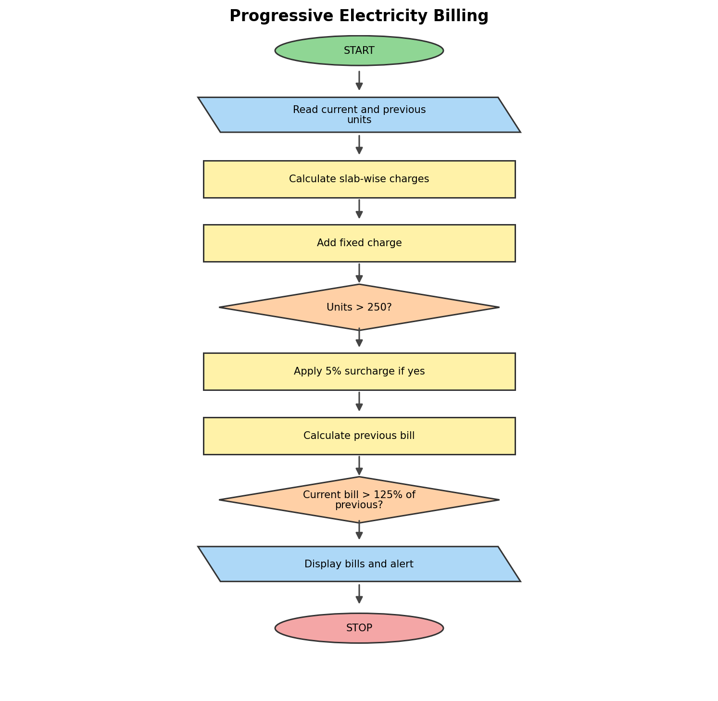

6. Pseudocode
name = input("Enter student name: ")
marks = float(input("Enter aggregate marks: "))
subject = float(input("Enter minimum subject score: "))
attendance = float(input("Enter attendance percentage: "))
income = float(input("Enter family annual income: "))

if marks >= 75 and subject >= 40 and attendance >= 75 and income <= 200000:
print("Student is Eligible for Scholarship")
print("Student Name:", name)
print("Aggregate Marks:", marks)
else:
print("Student is Not Eligible for Scholarship")

7. Python Source Code

marks = float(input("Enter aggregate marks: "))

subject = float(input("Enter subject score: "))

attendance = float(input("Enter attendance: "))

income = float(input("Enter family income: "))

if marks >= 75 and subject >= 40 and attendance >= 75 and income <= 200000:

print("Scholarship Eligible")

else:

print("Scholarship Not Eligible")

8. Test Cases

Aggregate Marks | Subject Score | Attendance (%) | Family Income (₹) | Expected Output
85 | 60 | 90 | 150000 | Scholarship Eligible
65 | 50 | 85 | 100000 | Scholarship Not Eligible
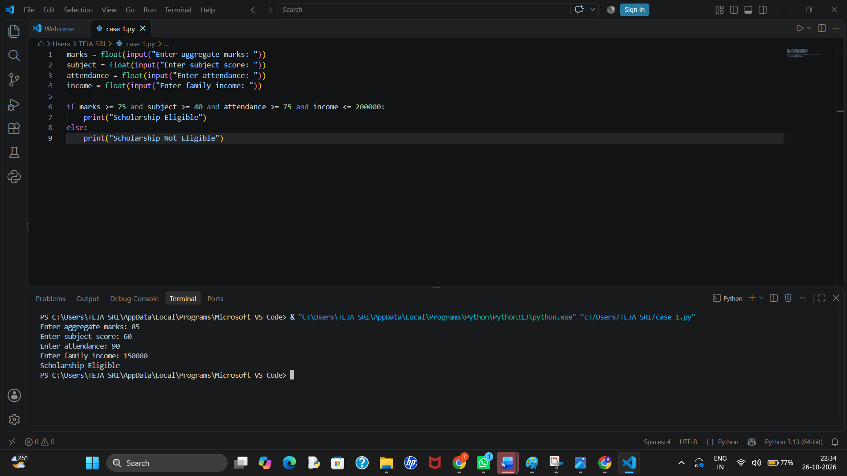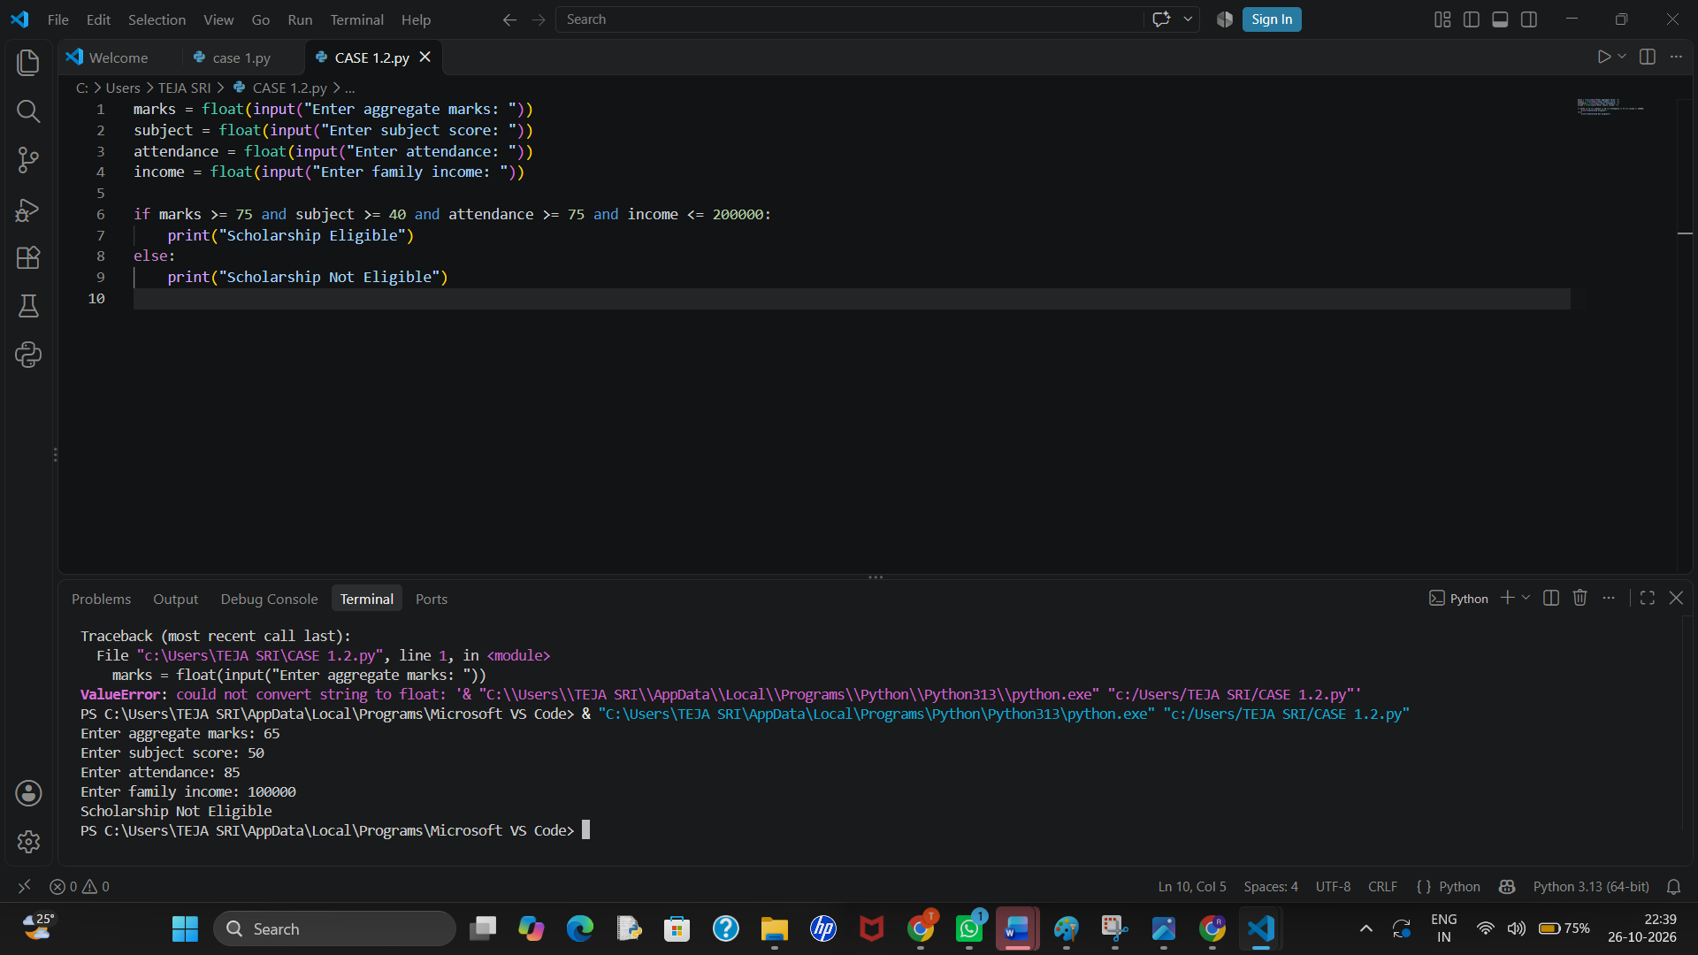

10. Conclusion
The program applies progressive rates and a conditional surcharge, then compares monthly bills to identify a potentially unusual increase.

2. Employee Payroll and Deduction Analysis

1. Problem Statement
Create a payroll program that calculates gross salary from basic pay, allowances, overtime, and incentives, applies a simple deduction policy, and prints a salary statement.

2. Objectives
- Compute gross earnings.
- Apply deductions using conditions.
- Display gross pay, deductions, and net pay.

3. Assumptions
- Basic pay, allowances, overtime pay, and incentives are non-negative.
- Gross salary is their sum.
- Deduction is 5% of gross up to ₹30,000; above ₹30,000, deduction is 8% of gross.

4. Algorithm
1. Read salary components.
2. Validate that values are non-negative.
3. Add components to calculate gross pay.
4. Choose the deduction rate based on gross pay.
5. Subtract deduction and print the salary statement.

5. Flowchart
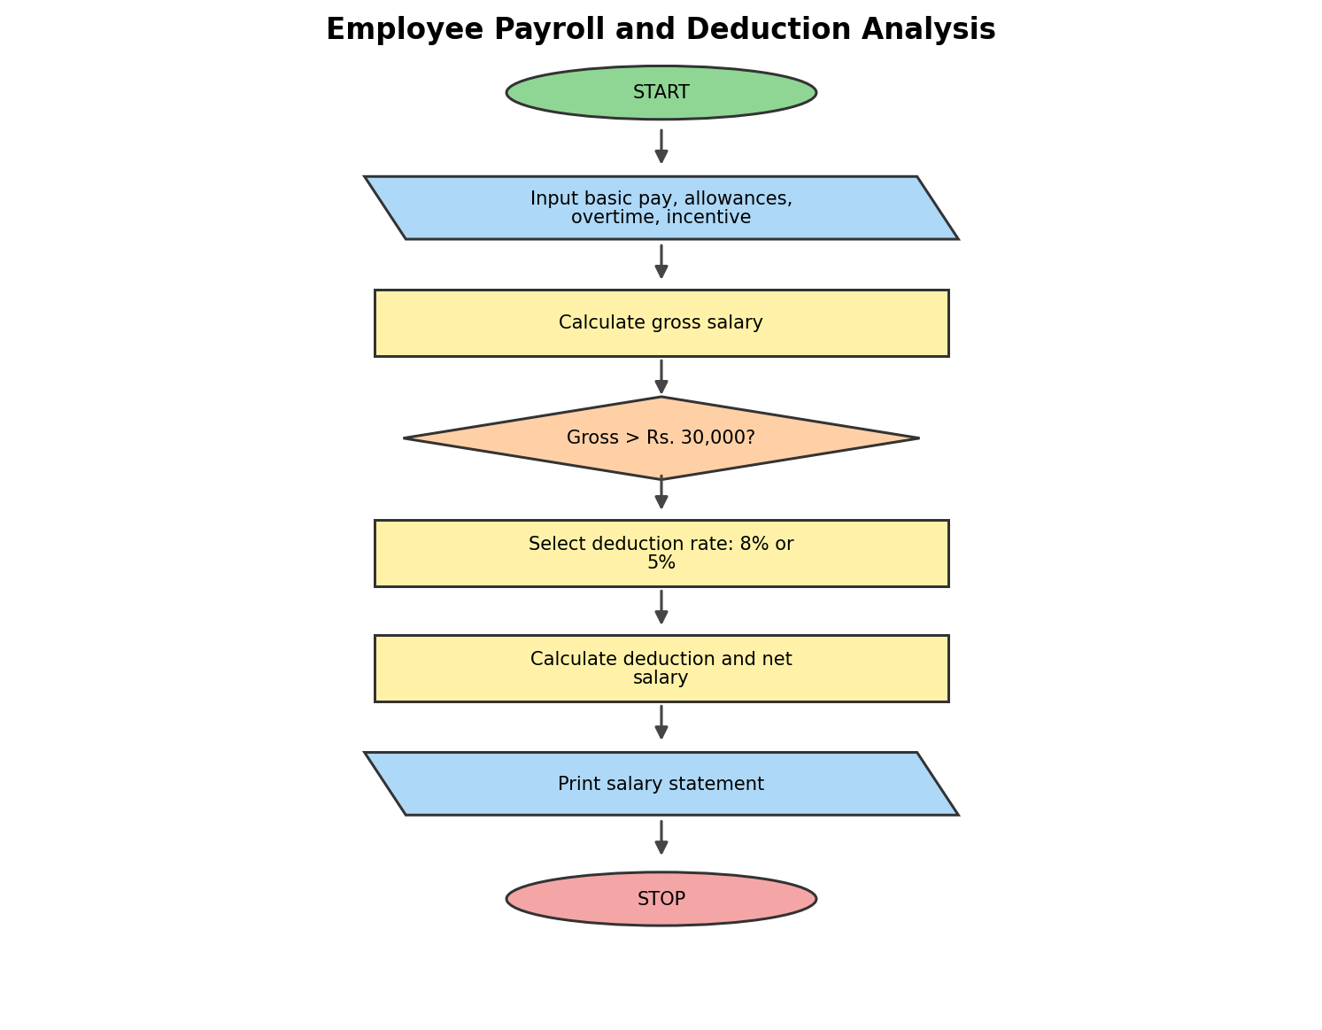

6. Pseudocode
BEGIN
INPUT units and previous bill
IF units <= 100, bill = units * 2
ELSE IF units <= 200, bill = 200 + (units-100)*3
ELSE, bill = 500 + (units-200)*5
ADD fixed charge and surcharge
IF bill > 1000, APPLY rebate
DISPLAY current bill
COMPARE with previous bill
DISPLAY unusual increase if bill > 1.5 * previous bill
END

7. Python Source Code
u = int(input("Enter units: "))
p = float(input("Enter previous bill: "))
b = u*2 if u <= 100 else 200+(u-100)*3 if u <= 200 else 500+(u-200)*5
b += 50 + (b+50)*0.05 - (50 if b+50 > 1000 else 0)
print("Bill:", round(b, 2), "Unusual Increase" if b > 1.5*p else "Normal Bill")

8. Test Cases
Input:
Enter units: 80
Enter previous bill: 200

Output:
Bill: 220.5 Normal Bill

Input:
Enter units: 250
Enter previous bill: 800

Output:
Bill: 1312.5 Unusual Increase

9. Output
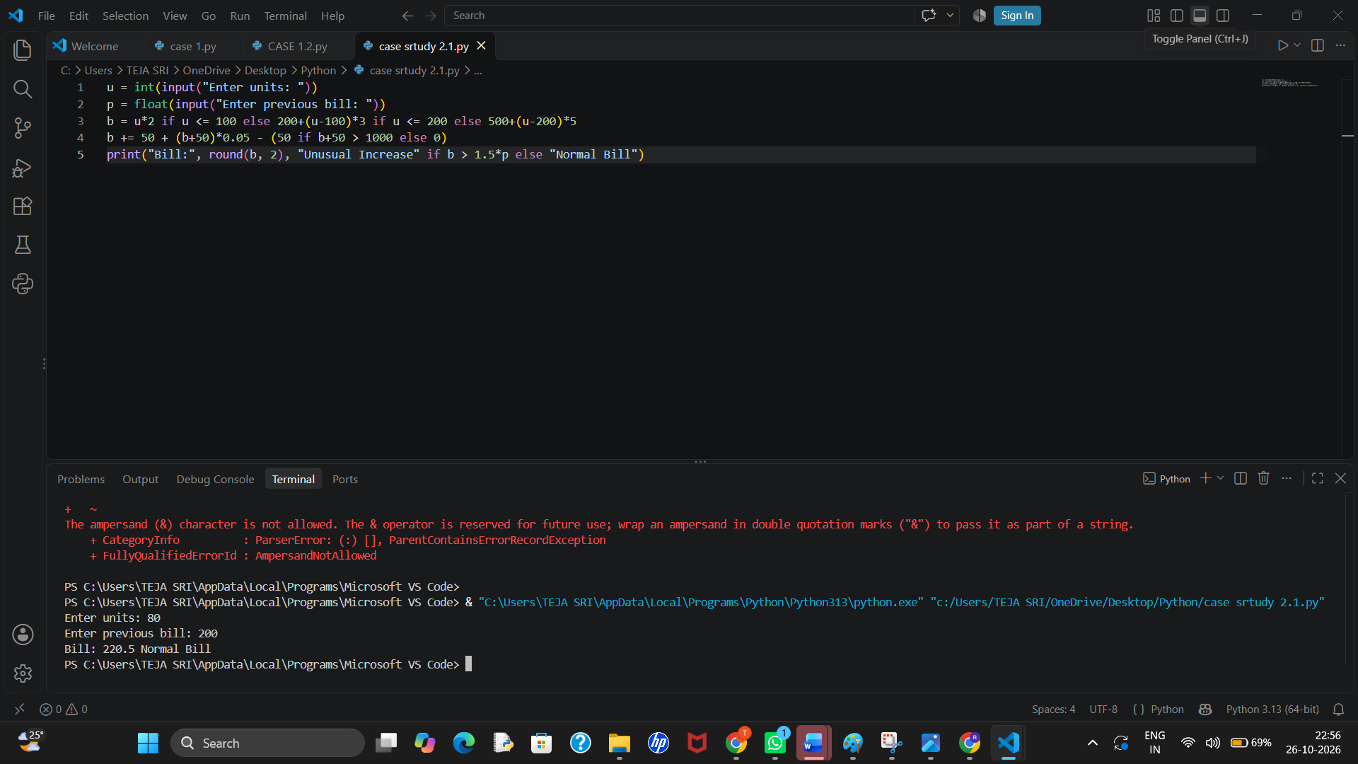

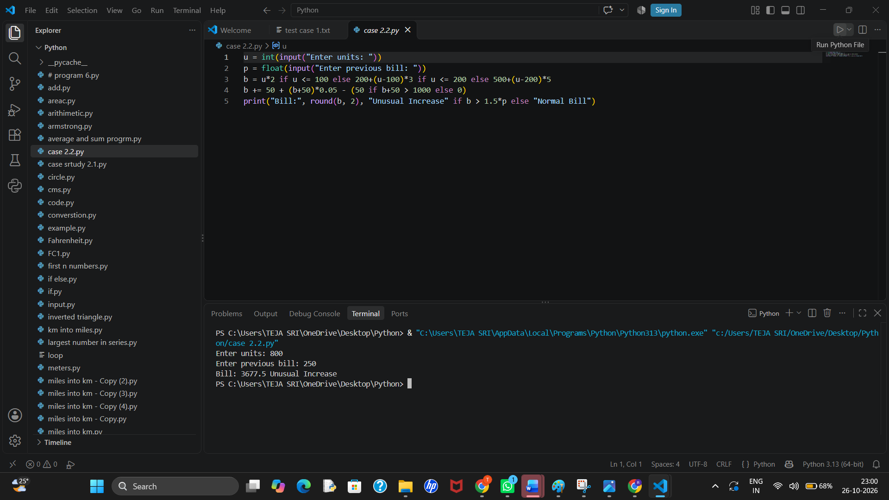

10. Conclusion
The payroll program calculates earnings and applies the stated deduction bands to obtain net salary.

3. Retail Billing with Discount Rules

1. Problem Statement
Develop an itemized retail bill for multiple products. Apply a discount when the pre-tax subtotal reaches a threshold, limit the discount to a maximum concession, and calculate tax on the discounted amount.

2. Objectives
- Calculate line totals and subtotal.
- Apply threshold-based discount with a cap.
- Calculate tax and final invoice amount.

3. Assumptions
- The example uses three products with quantity and unit price.
- A 10% discount applies when subtotal is at least ₹1,000; maximum discount is ₹150.
- Tax is 5% of the subtotal after discount.

4. Algorithm
1. Store product names, prices, and quantities in a list.
2. Calculate each line total and subtotal.
3. Apply discount condition and maximum cap.
4. Calculate tax and final total.
5. Print the itemized invoice.

5. Flowchart
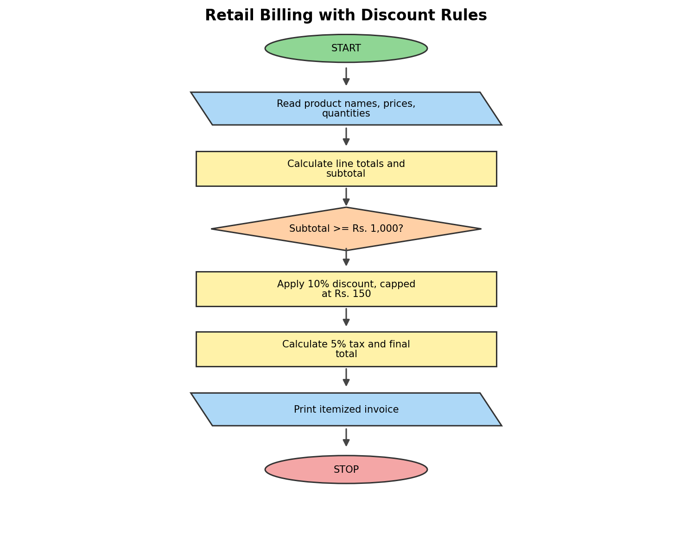

6. Pseudocode
BEGIN
INPUT consultation, diagnosis, treatment charges
CALCULATE total bill
IF total bill > 5000, apply 10% concession
CALCULATE final bill
IF final bill <= 3000, classify as Low
ELSE IF final bill <= 7000, classify as Medium
ELSE classify as High
DISPLAY final bill and classification
END

7. Python Source Code
c = float(input("Consultation charge: "))
d = float(input("Diagnostic charge: "))
t = float(input("Treatment charge: "))
b = c + d + t
if b > 5000: b *= 0.90
print("Final Bill:", b)
print("Category:", "Low" if b <= 3000 else "Medium" if b <= 7000 else "High")

8. Test Cases
Input:
Consultation: 500
Diagnostic: 1000
Treatment: 1000
Output:
Final Bill: 2500.0
Category: Low
Input:
Consultation: 1000
Diagnostic: 2000
Treatment: 3000

Output:
Final Bill: 5400.0
Category: Medium

9. Output
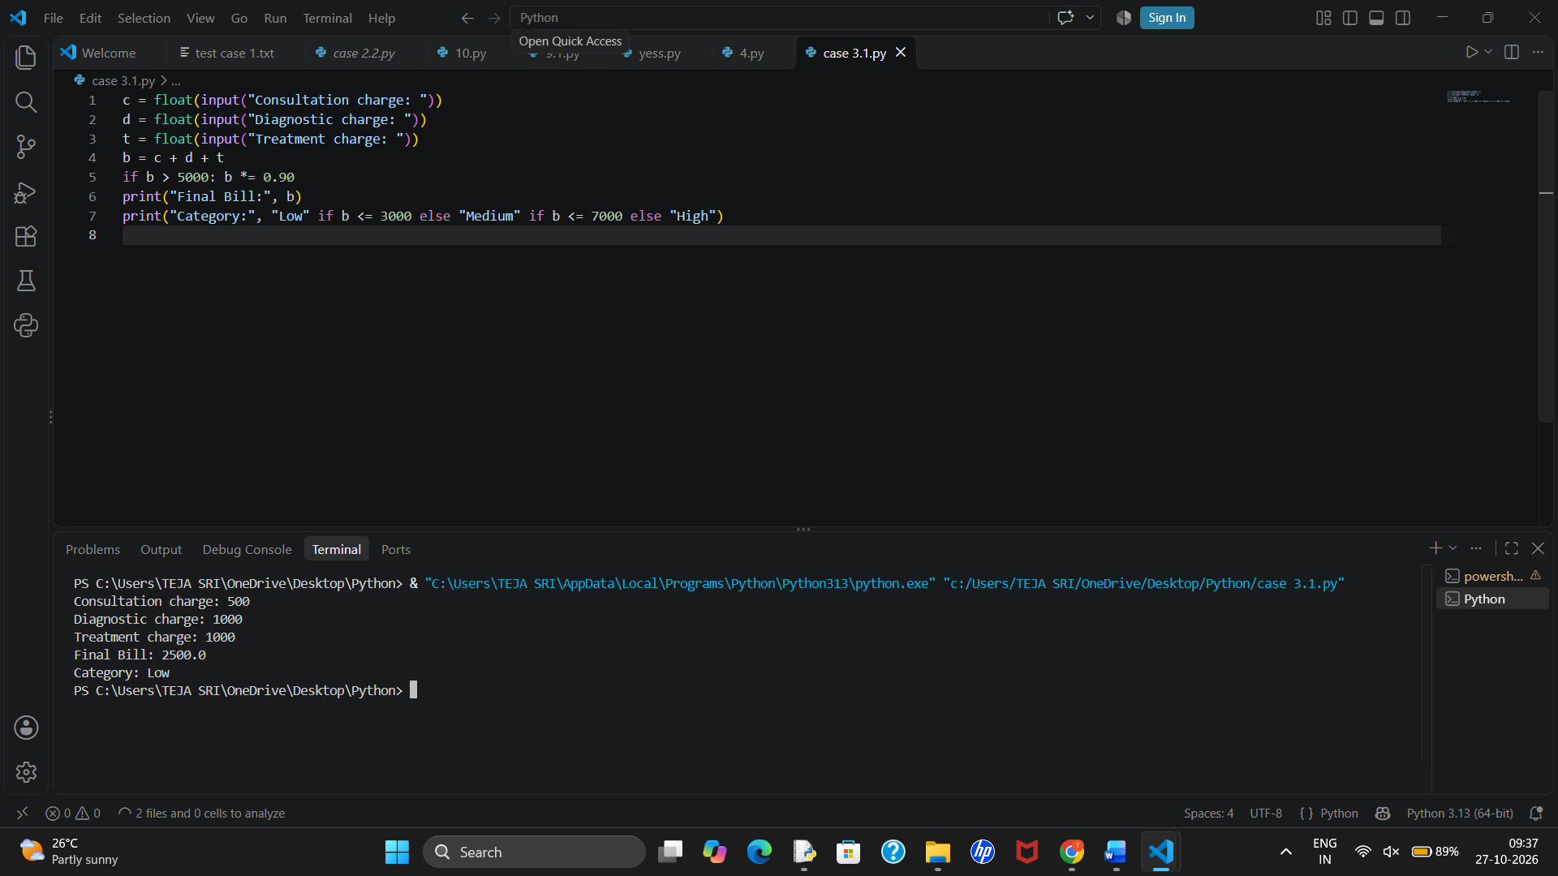
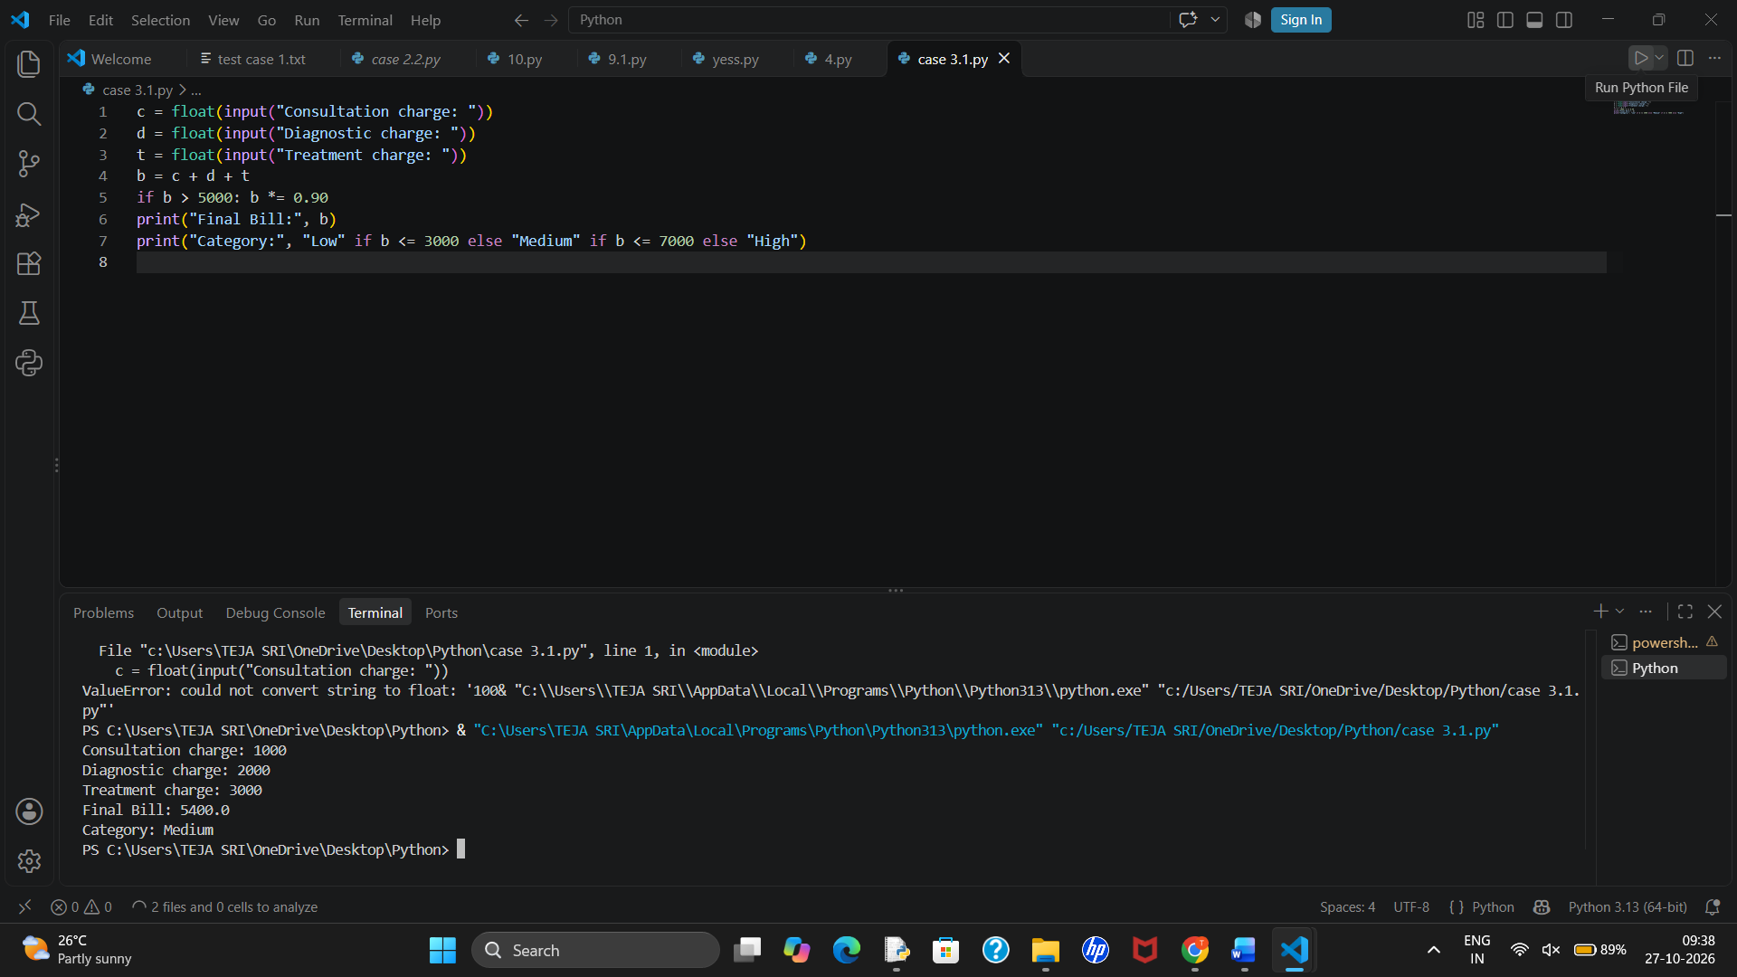

10. Conclusion
The invoice program demonstrates lists, loops, arithmetic, conditional discounts, and a capped concession before tax.

4. Examination Result and Grace-Mark Validation

1. Problem Statement
Process marks in multiple subjects, check subject-wise pass criteria, apply a limited grace-mark policy, and generate a final result without exceeding maximum marks.

2. Objectives
- Check each subject against the pass mark.
- Use grace marks only within the stated limit.
- Calculate total, percentage, and final status.

3. Assumptions
- Marks are out of 100 and the pass mark is 40 per subject.
- At most 3 grace marks may be added to one subject that is short by no more than 3 marks.
- Final marks cannot exceed 100.

4. Algorithm
1. Store subject marks in a dictionary.
2. For each subject, if marks are 37–39, add enough grace marks to reach 40, within the 3-mark limit.
3. Check whether all subjects pass.
4. Calculate total and percentage and display the result.

5. Flowchart
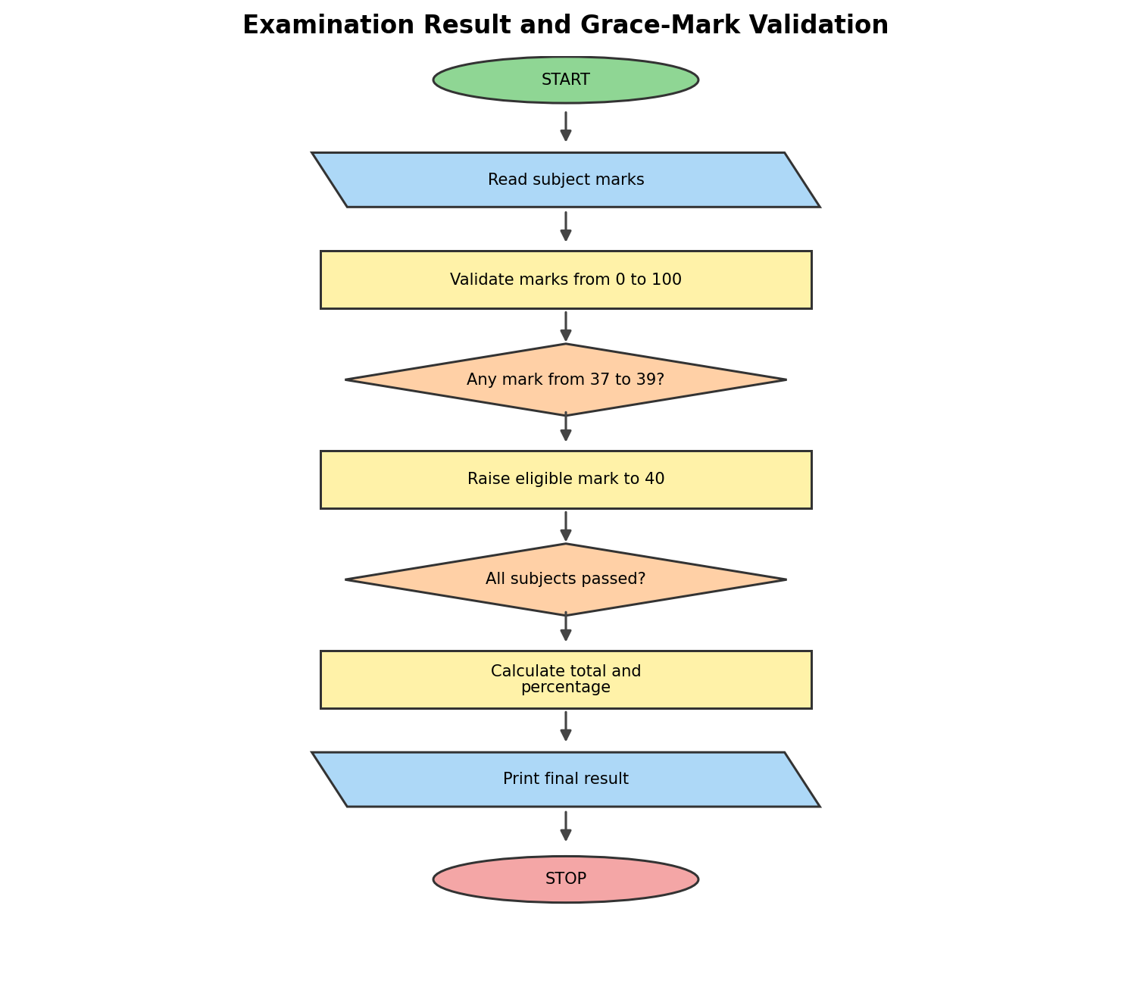

6. Pseudocode
BEGIN
INPUT basic salary, allowances, overtime, incentives
CALCULATE gross salary
IF gross salary <= 20000, deduction = 5%
ELSE deduction = 10%
CALCULATE net salary
DISPLAY gross salary, deduction and net salary
END

7. Python Source Code
b = float(input("Basic salary: "))
a = float(input("Allowances: "))
o = float(input("Overtime: "))
i = float(input("Incentives: "))
g = b + a + o + i
d = g * 0.05 if g <= 20000 else g * 0.10
print("Gross:", g, "Deduction:", d, "Net Salary:", g-d)

8. Test Cases
Input:
Basic salary: 15000
Allowances: 2000
Overtime: 1000
Incentives: 500
Output:
Gross: 18500.0
Deduction: 925.0
Net Salary: 17575.0

9. Output

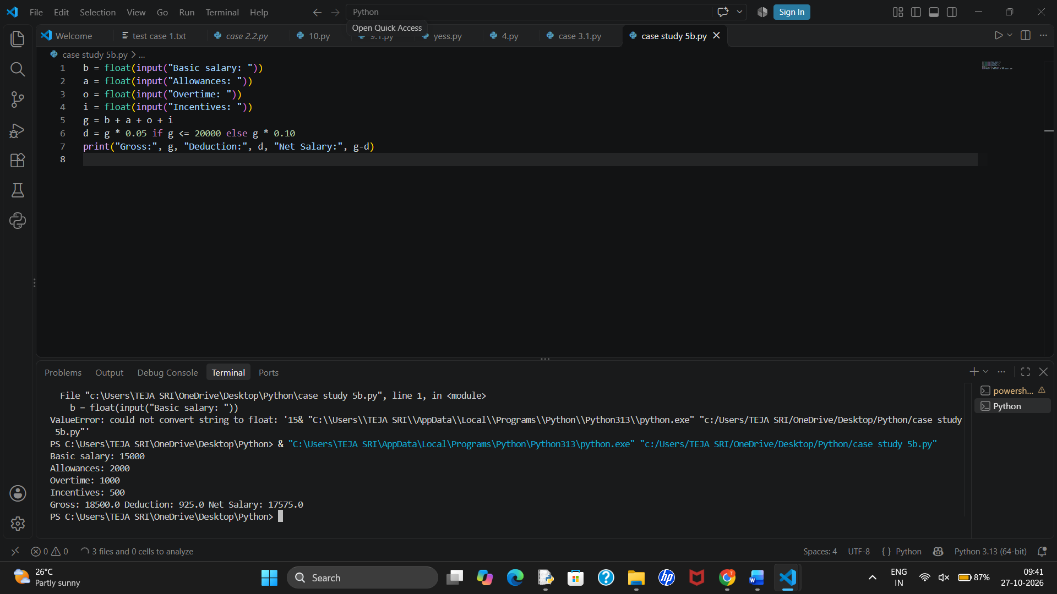

10. Conclusion
The program validates marks, applies the defined grace rule, and determines the result using subject-wise pass conditions.

5. ATM Transaction Sequence Simulation

1. Problem Statement
Simulate a series of deposits and withdrawals, update an account balance, reject invalid or unaffordable withdrawals, and summarize accepted and rejected transactions.

2. Objectives
- Update balance after each transaction.
- Reject invalid amounts and withdrawals exceeding balance.
- Report final balance and transaction counts.

3. Assumptions
- Opening balance is ₹5,000.
- Transactions are tuples of type and amount.
- Withdrawal limit per transaction is ₹3,000.
- Amounts must be positive.

4. Algorithm
1. Set the opening balance and counters.
2. Process each transaction tuple.
3. Accept deposits with positive amounts.
4. Accept withdrawals only if within limit and balance.
5. Print each decision and final summary.

5. Flowchart
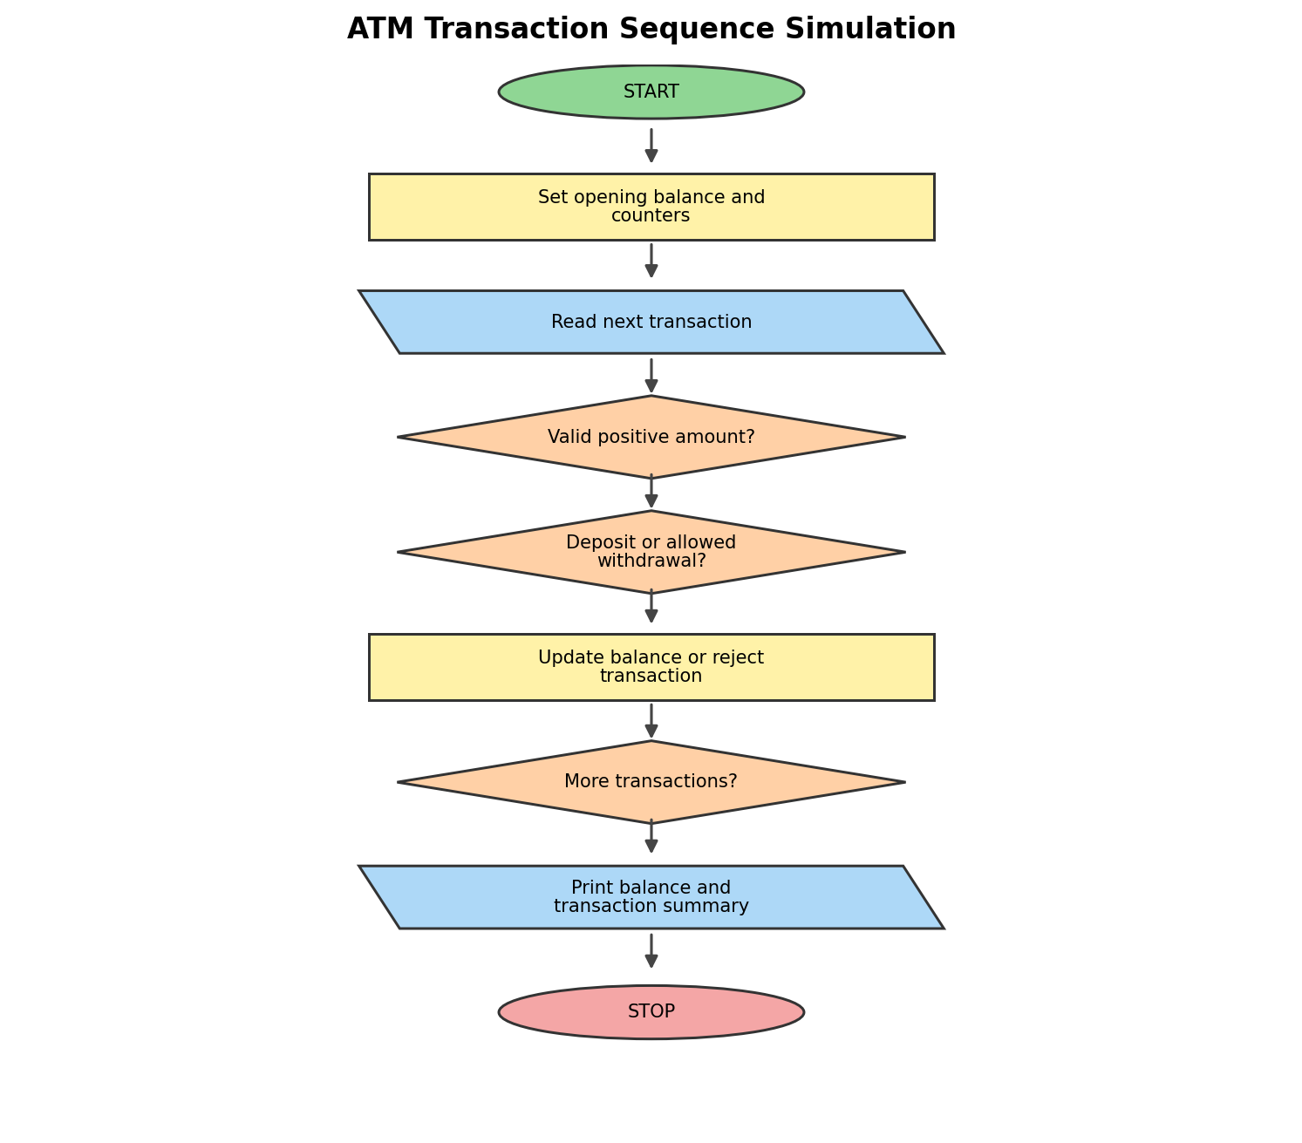

6. PseudocodeEND

7. BEGIN

INPUT monthly usage

CALCULATE cost for Plan A and Plan B

IF usage <= 100, Plan A costs 200

ELSE add excess usage charges

IF usage <= 200, Plan B costs 300

ELSE add excess usage charges

COMPARE plan costs

DISPLAY the cheapest plan

END

Python Source Code
u = int(input("Enter monthly usage in units: "))
a = 200 if u <= 100 else 200 + (u-100)*2
b = 300 if u <= 200 else 300 + (u-200)*1
print("Plan A:", a, "Plan B:", b)
print("Best Plan:", "A" if a <= b else "B")

8. Test Cases
Input:
Enter monthly usage in units: 80
Output:
Plan A: 200
Plan B: 300
Best Plan: A
Input:
Enter monthly usage in units: 250

Output:
Plan A: 500
Plan B: 350
Best Plan: B

9. Output

10. Conclusion
The simulation tracks the account balance accurately and rejects transactions that violate the amount, balance, or withdrawal-limit rules.

6. Warehouse Inventory Reconciliation

1. Problem Statement
Compare opening stock, received stock, dispatched stock, and physically counted closing stock for several products. Detect discrepancies and calculate replenishment needed to reach a target stock.

2. Objectives
- Calculate expected closing stock.
- Compare expected and physical stock.
- Calculate discrepancies and target replenishment.

3. Assumptions
- Expected stock = opening + received − dispatched.
- A negative expected stock is invalid.
- Target stock is 20 units for each product.
- Discrepancy = physical closing − expected closing.

4. Algorithm
1. Store each product record as a tuple.
2. Calculate expected closing quantity.
3. Compare with physical closing quantity.
4. Calculate replenishment to target if stock is below target.
5. Display reconciliation results.

5. Flowchart
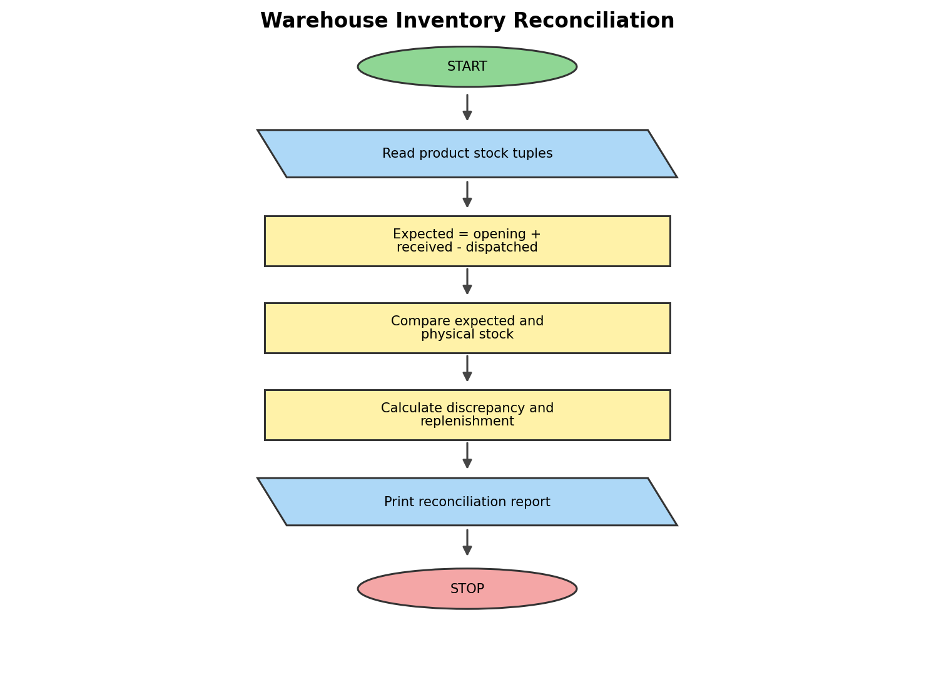

6. Pseudocode

BEGIN

INPUT distance, age, class, cancellation

CALCULATE fare based on distance

ADD reservation fee

IF age >= 60, APPLY 20% concession

IF cancellation = yes, ADD cancellation penalty

DISPLAY final fare

END

7. Python Source Code
d = int(input("Enter distance: "))
age = int(input("Enter age: "))
c = input("Enter class (A/B): ").upper()
fare = d * (3 if c == "A" else 2)
if age >= 60:
fare *= 0.8
fare += 50
if input("Cancel ticket? (yes/no): ").lower() == "yes":
fare += 100
print("Final Fare:", round(fare, 2))

8. Test Cases
Input:
Distance: 100
Age: 30
Class: B
Cancel ticket? no
Output:
Final Fare: 250.0
Input:

9. Output
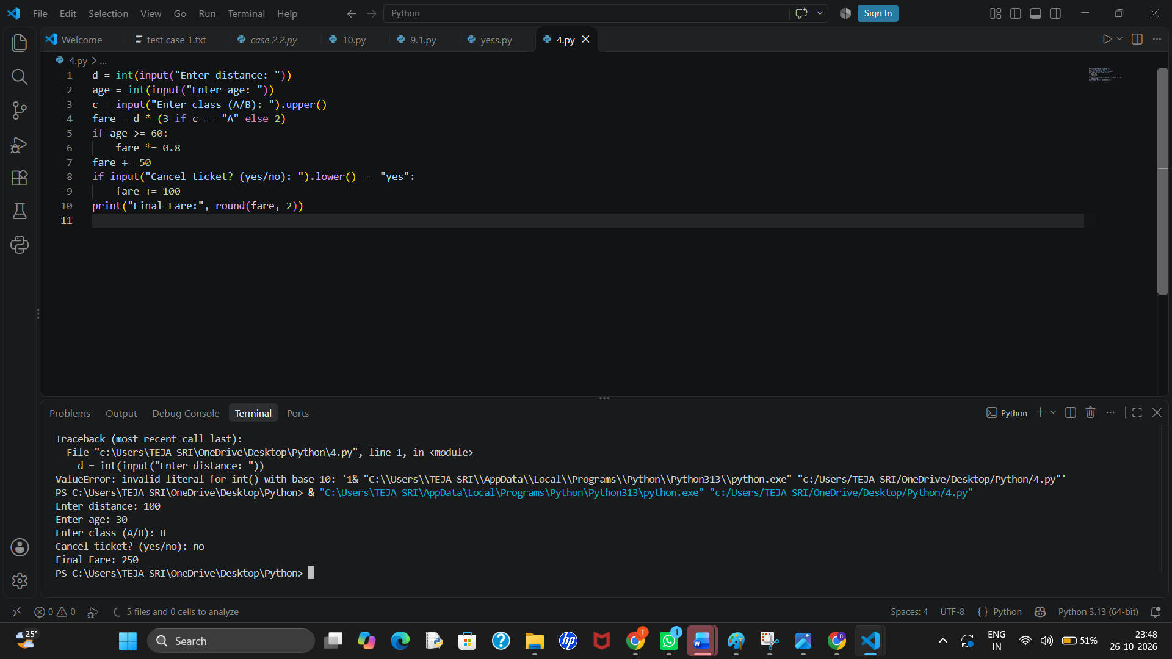

10. Conclusion
The program uses tuples and arithmetic to reconcile stock records, identify mismatches, and calculate replenishment requirements.

7. Student Performance Trend Analysis

1. Problem Statement
Compare student scores across three assessments, calculate changes, identify subjects consistently below a defined threshold, and classify the overall trend.

2. Objectives
- Calculate improvement or decline between assessments.
- Identify consistently weak subjects.
- Classify performance using average marks.

3. Assumptions
- Scores are out of 100.
- The dataset contains three assessments per subject.
- A subject is consistently weak if all three scores are below 40.
- Average ≥ 75 is High, ≥ 50 is Moderate, otherwise Needs Improvement.

4. Algorithm
1. Store subject scores as nested lists.
2. Calculate change from first to last assessment.
3. Check for consistently weak subjects.
4. Calculate overall average and classify.
5. Print a summary.

5. Flowchart
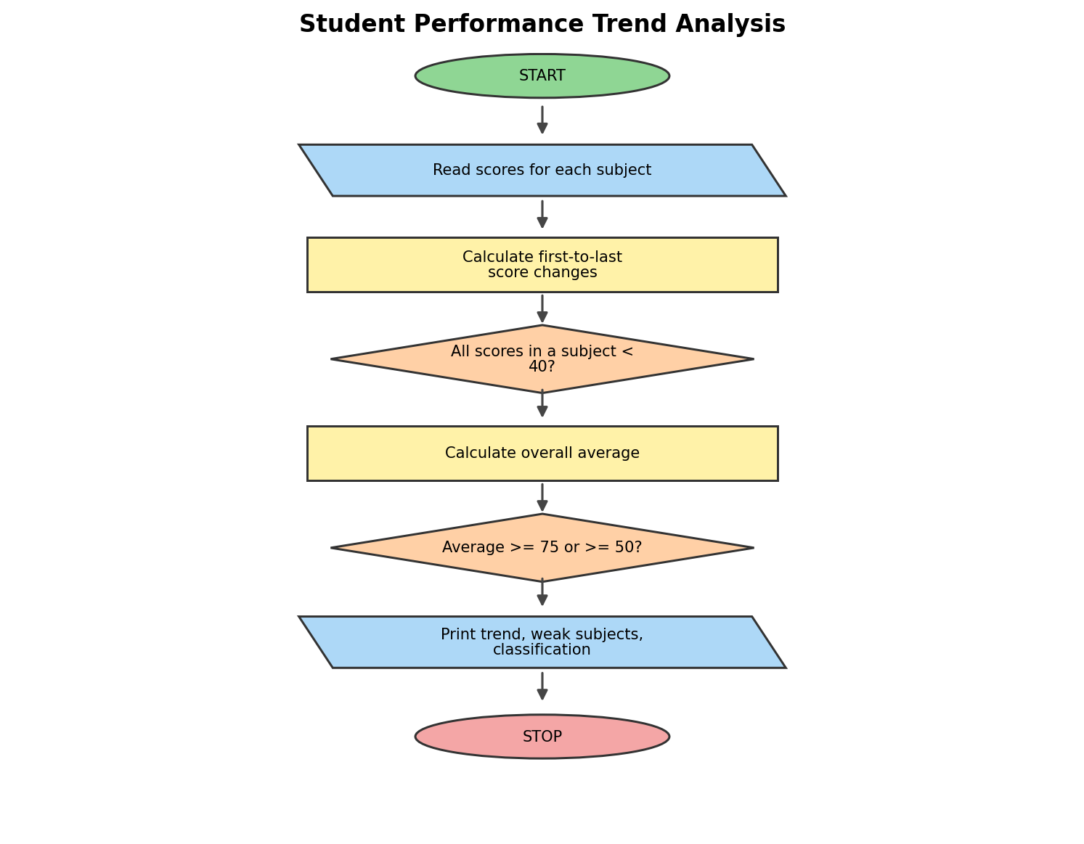

6. Pseudocode
BEGIN
INPUT product price and quantity
CALCULATE total amount
IF total >= 1000, APPLY 10% discount
LIMIT discount to 200
ADD 5% tax
DISPLAY final bill
END

7. Python Source Code
p = float(input("Enter product price: "))
q = int(input("Enter quantity: "))
total = p * q
discount = min(total * 0.10, 200) if total >= 1000 else 0
bill = (total - discount) * 1.05
print("Total Bill:", round(bill, 2))

8. Test Cases
Input:
Price: 200
Quantity: 22
Output:
Total Bill: 420.0

9. Output
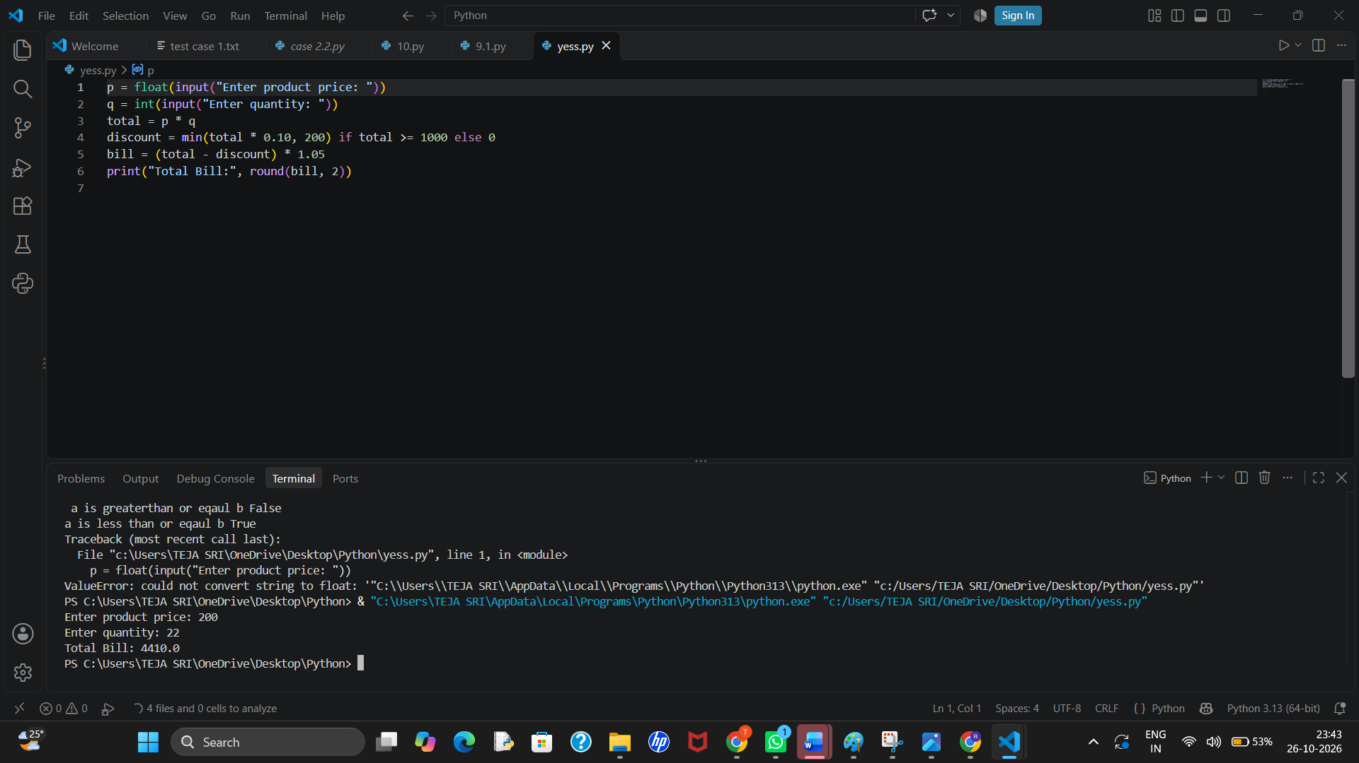

10. Conclusion
The analysis identifies score trends and consistently weak subjects and classifies overall performance using clear thresholds.

8. Password Policy Validation Engine

1. Problem Statement
Validate sample passwords against minimum length, uppercase, lowercase, digit, special-character, repeated-character, and prohibited-substring rules. Report each failed rule.

2. Objectives
- Check password length and character categories.
- Detect repeated consecutive characters.
- Report all failed policy conditions.

3. Assumptions
- Minimum length is 8 characters.
- Password must contain uppercase, lowercase, digit, and one of !, @, #, $.
- Three identical consecutive characters are prohibited.
- The substring 'password' is prohibited regardless of letter case.

4. Algorithm
1. Read a sample password.
2. Check each required condition.
3. Check for three consecutive identical characters.
4. Check prohibited substring case-insensitively.
5. Print failures or valid status.

5. Flowchart
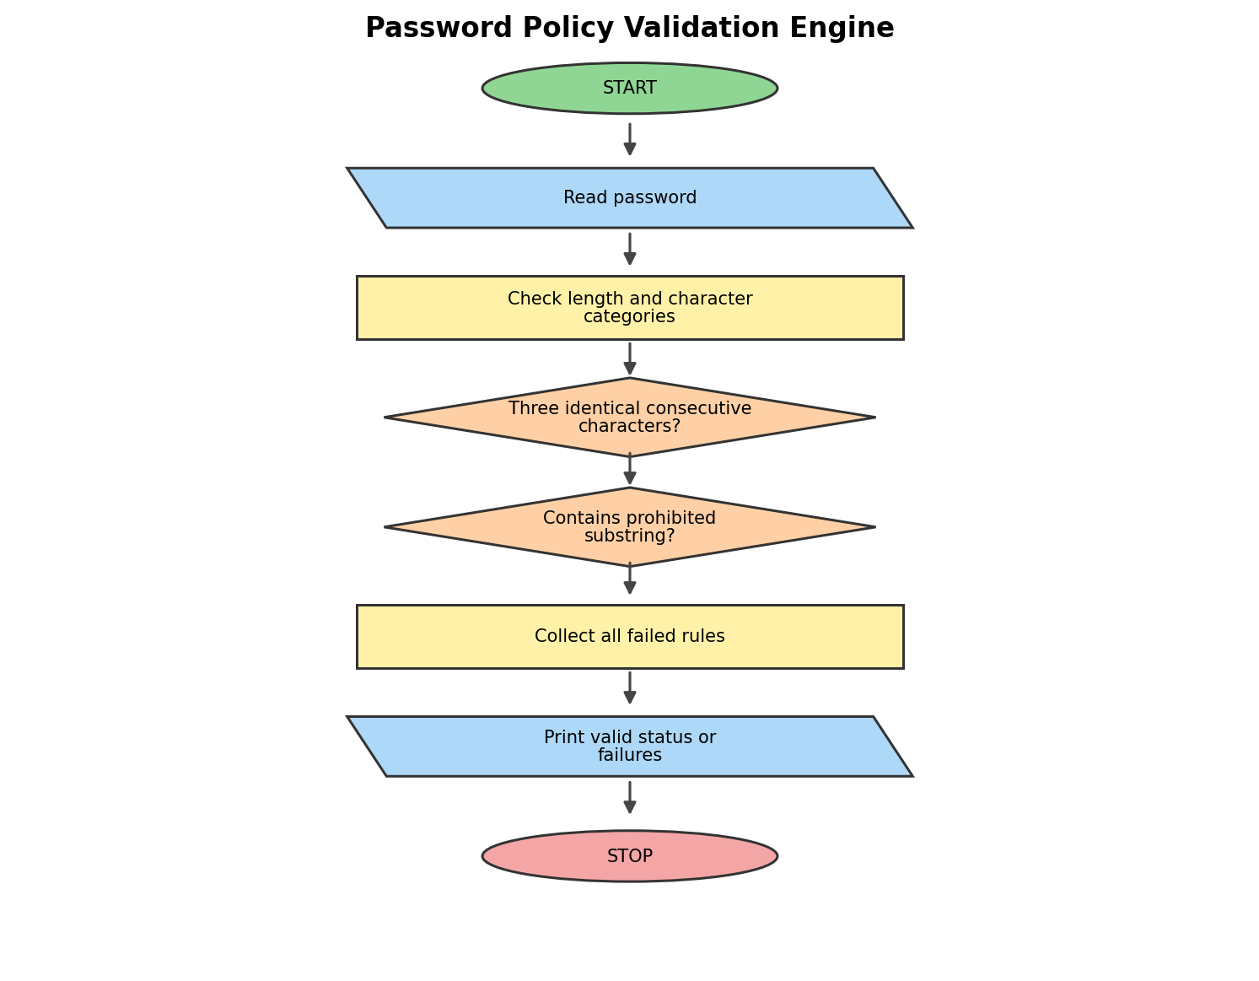

6. Pseudocode
BEGIN
INPUT material, labour, machine cost
INPUT wastage percentage and selling price
CALCULATE total production cost including wastage
CALCULATE profit
IF profit >= target, DISPLAY target achieved
ELSE DISPLAY target not achieved
DISPLAY cost and profit
END

7. Python Source Code
m = float(input("Material cost: "))
l = float(input("Labour cost: "))
mc = float(input("Machine cost: "))
w = float(input("Wastage percentage: "))
s = float(input("Selling price: "))
cost = (m + l + mc) * (1 + w / 100)
profit = s - cost
print("Total Cost:", round(cost, 2))
print("Profit:", round(profit, 2))
print("Target Achieved" if profit >= 500 else "Target Not Achieved")

8. Test Cases
Input:
Material: 500
Labour: 200
Machine: 1005
Wastage: 10
Selling price: 1500
Output:
Total Cost: 880.0
Profit: 620.0
Target Achieved
Input:
Material: 600
Labour: 300
Machine: 200
Wastage: 10
Selling price: 1200
Output:
Total Cost: 1210.0
Profit: -10.0
Target Not Achieved

9. Output
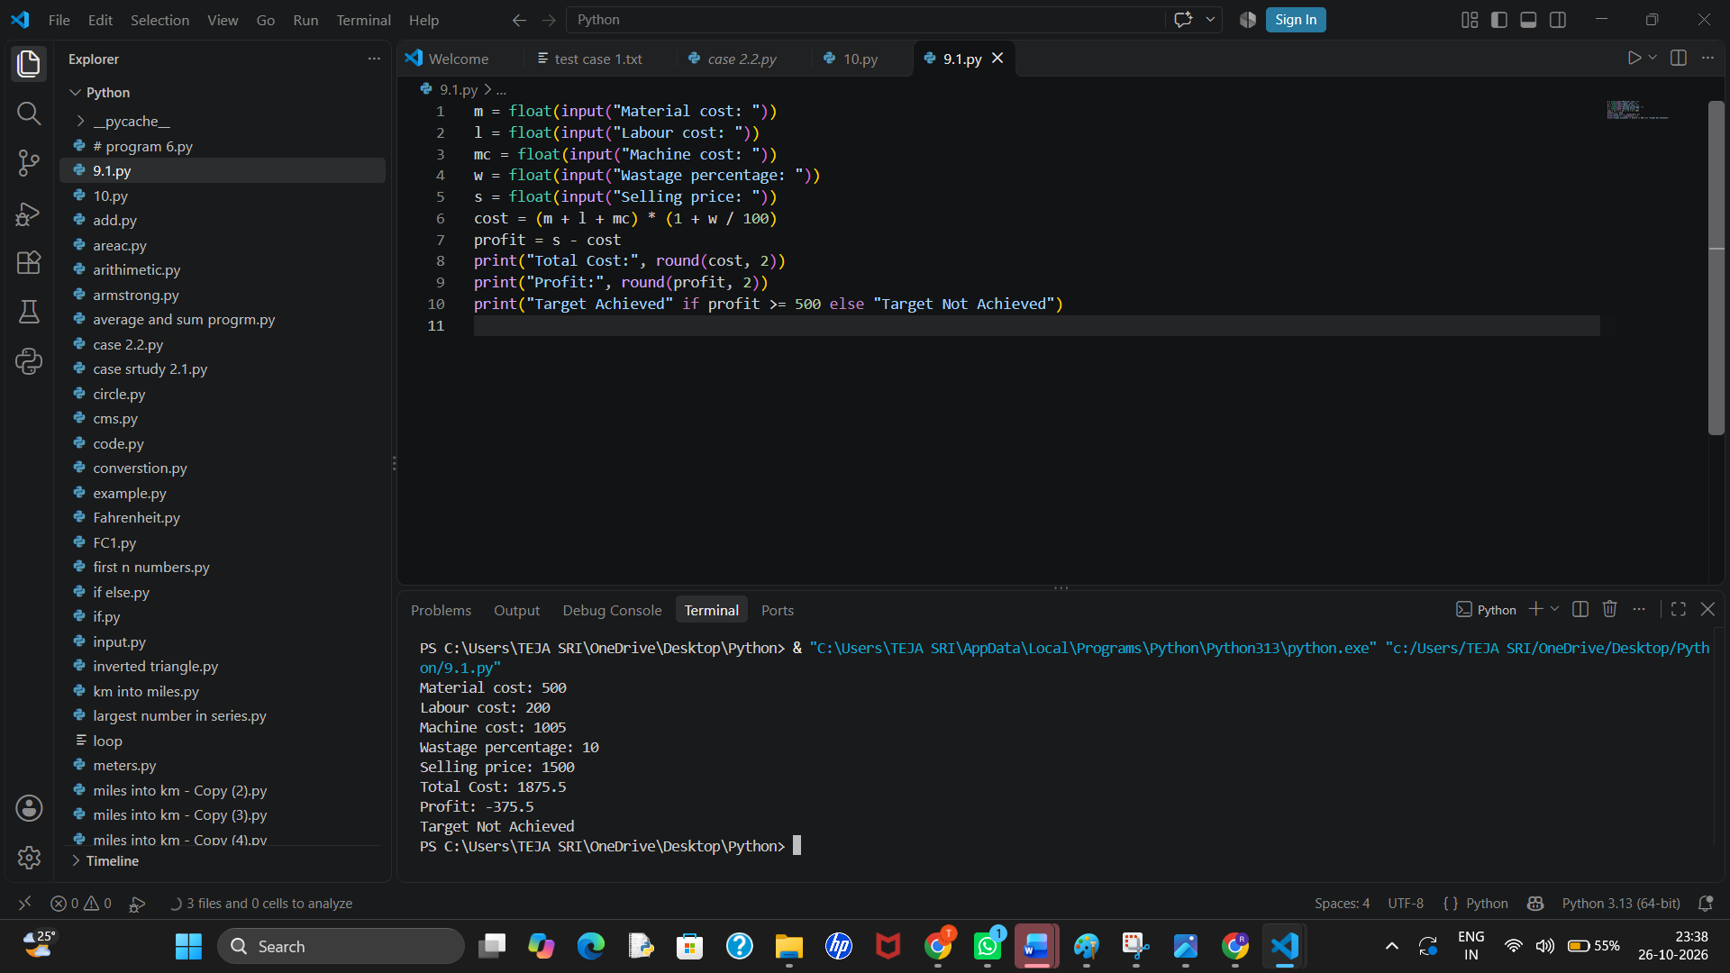
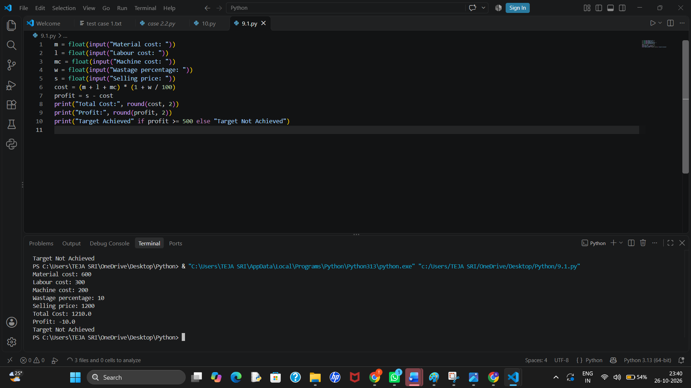

10. Conclusion
The validator checks multiple independent rules and reports specific failures, making the result more useful than a simple valid/invalid response.

9. Student Marks Matrix Analysis

1. Problem Statement
Analyse a nested list of student marks across subjects. Calculate each student's total and average, calculate subject averages, identify the top performer, and flag subjects with low averages.

2. Objectives
- Use a nested list to represent a marks matrix.
- Calculate row-wise and column-wise statistics.
- Identify top performer and low-average subjects.

3. Assumptions
- Rows represent students and columns represent Python, Maths, and English.
- Each mark is between 0 and 100.
- A subject average below 50 is considered low.

4. Algorithm
1. Create the marks matrix and student/subject labels.
2. Calculate each student's total and average.
3. Calculate each subject's average.
4. Identify the student with the highest total.
5. List subjects with average below 50.

5. Flowchart
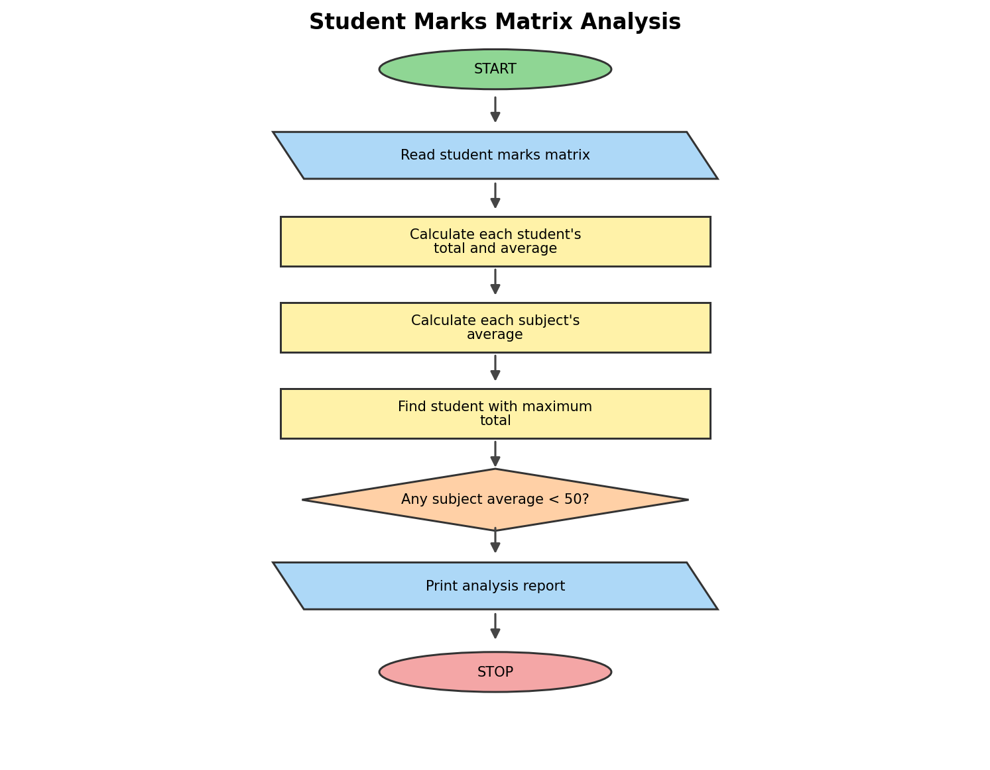

6. Pseudocode
BEGIN
INPUT expense in foreign currency
INPUT exchange rate and conversion fee
CONVERT expense into local currency
ADD conversion fee
COMPARE total expense with budget
DISPLAY largest expense category
END

7. Python Source Code
amount = float(input("Enter foreign expense: "))
rate = float(input("Enter exchange rate: "))
fee = float(input("Enter conversion fee: "))
budget = float(input("Enter budget: "))
total = amount * rate + fee
print("Total Expense:", total)
print("Within Budget" if total <= budget else "Over Budget")

8. Test Cases

Input:
Foreign expense: 100
Exchange rate: 80
Fee: 50
Budget: 10000
Output:
Total Expense: 8050.0
Within Budget
Input:
Foreign expense: 150
Exchange rate: 80
Fee: 100
Budget: 10000

Output:
Total Expense: 12100.0
Over Budget

9. Output
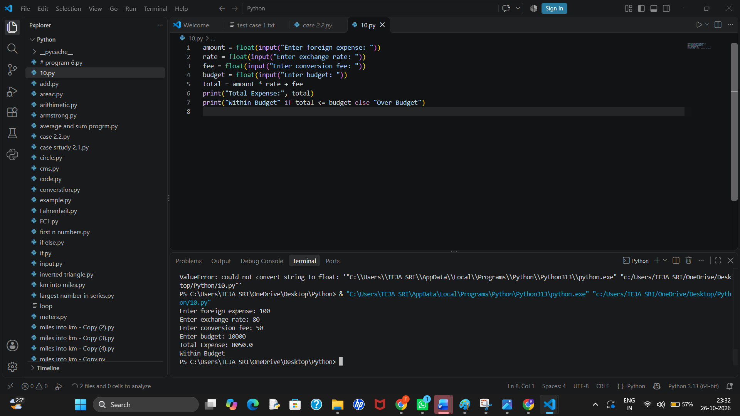
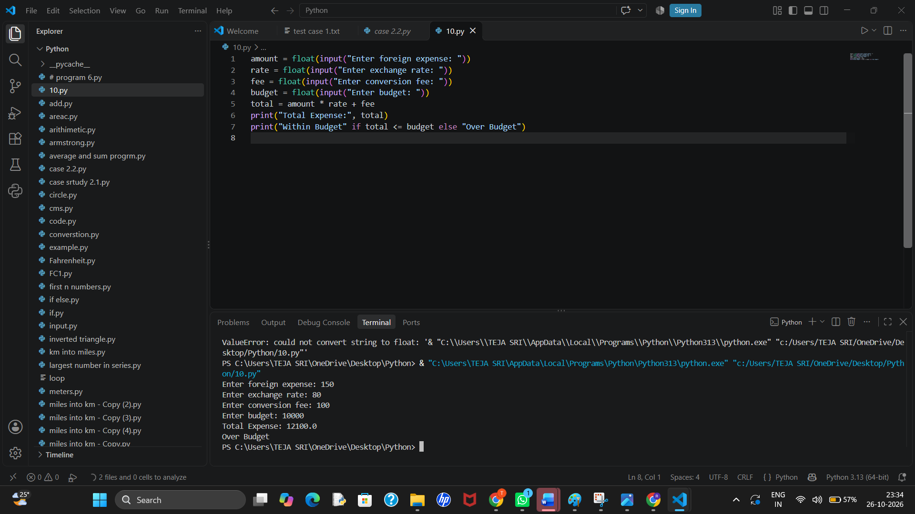

10. Conclusion
The marks matrix demonstrates nested-list processing, row and column calculations, and identification of the highest-performing student.

10. Food Waste Monitoring System

1. Problem Statement
Compare meals prepared, meals served, and leftovers over several days. Calculate waste percentages and identify days where waste exceeds an acceptable threshold.

2. Objectives
- Calculate leftover meals and waste percentage.
- Compare daily waste against a threshold.
- Summarize total waste over the period.

3. Assumptions
- Meals prepared and served are non-negative integers.
- Leftovers = prepared − served.
- Waste percentage = leftovers / prepared × 100.
- A day is flagged if waste percentage exceeds 10%; prepared meals must be greater than zero.

4. Algorithm
1. Store daily prepared and served counts in a list of tuples.
2. Calculate leftovers and percentage for each day.
3. Flag waste percentages above 10%.
4. Sum total prepared, served, and leftover meals.
5. Print daily and overall results.

5. Flowchart
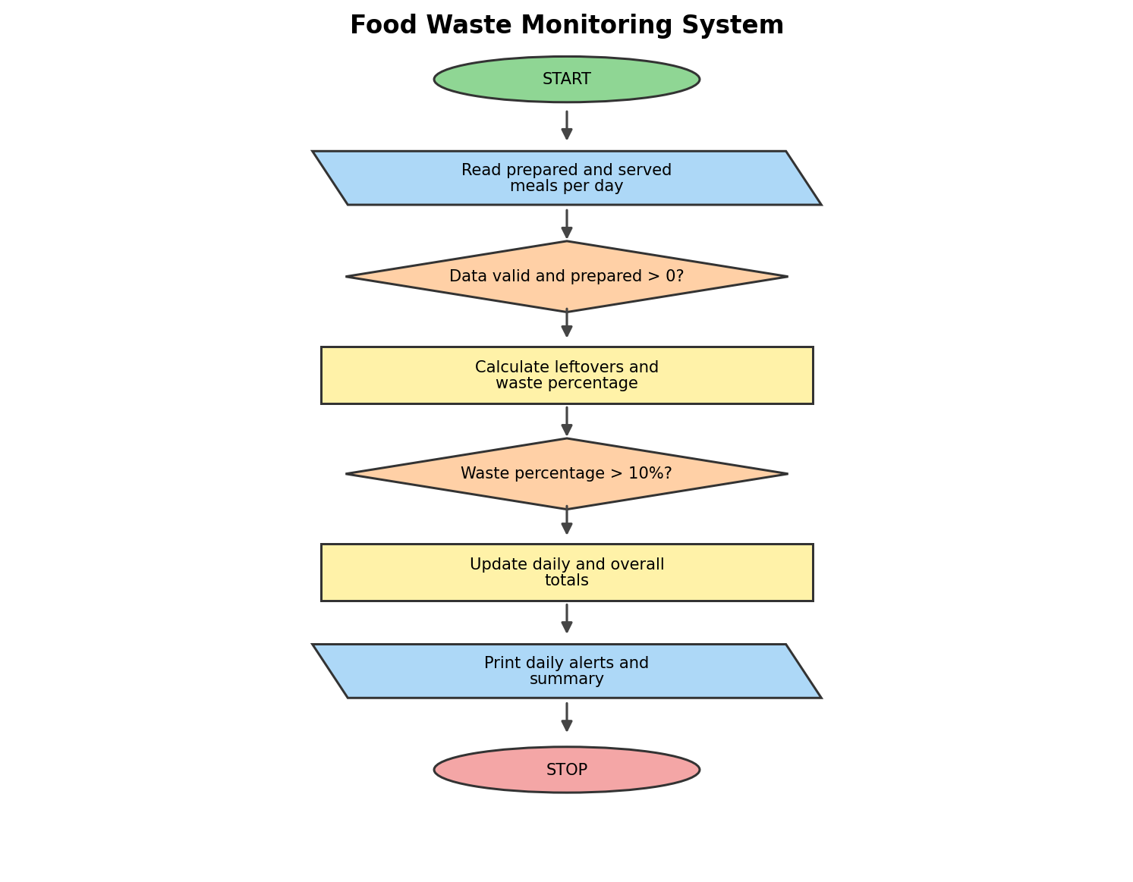

6. Pseudocode
BEGIN
INPUT venue, equipment, catering, transport and certificate costs
INPUT sponsorship and participant contribution
CALCULATE total cost
CALCULATE shortfall after sponsorship
CALCULATE minimum participants needed
DISPLAY total cost and shortfall
END

7. Python Source Code
v = float(input("Venue cost: "))
e = float(input("Equipment cost: "))
c = float(input("Catering cost: "))
t = float(input("Transport cost: "))
s = float(input("Sponsorship: "))
fee = float(input("Contribution per participant: "))
total = v + e + c + t
shortfall = max(0, total - s)
print("Total Cost:", total)
print("Shortfall:", shortfall)
print("Participants Needed:", int(shortfall / fee) + (shortfall % fee > 0))

8. Test Cases
Input:
Venue: 5000
Equipment: 2000
Catering: 3000
Transport: 1000
Sponsorship: 5000
Contribution: 100
Output:
Total Cost: 11000.0
Shortfall: 6000.0
Participants Needed: 60

9. Output
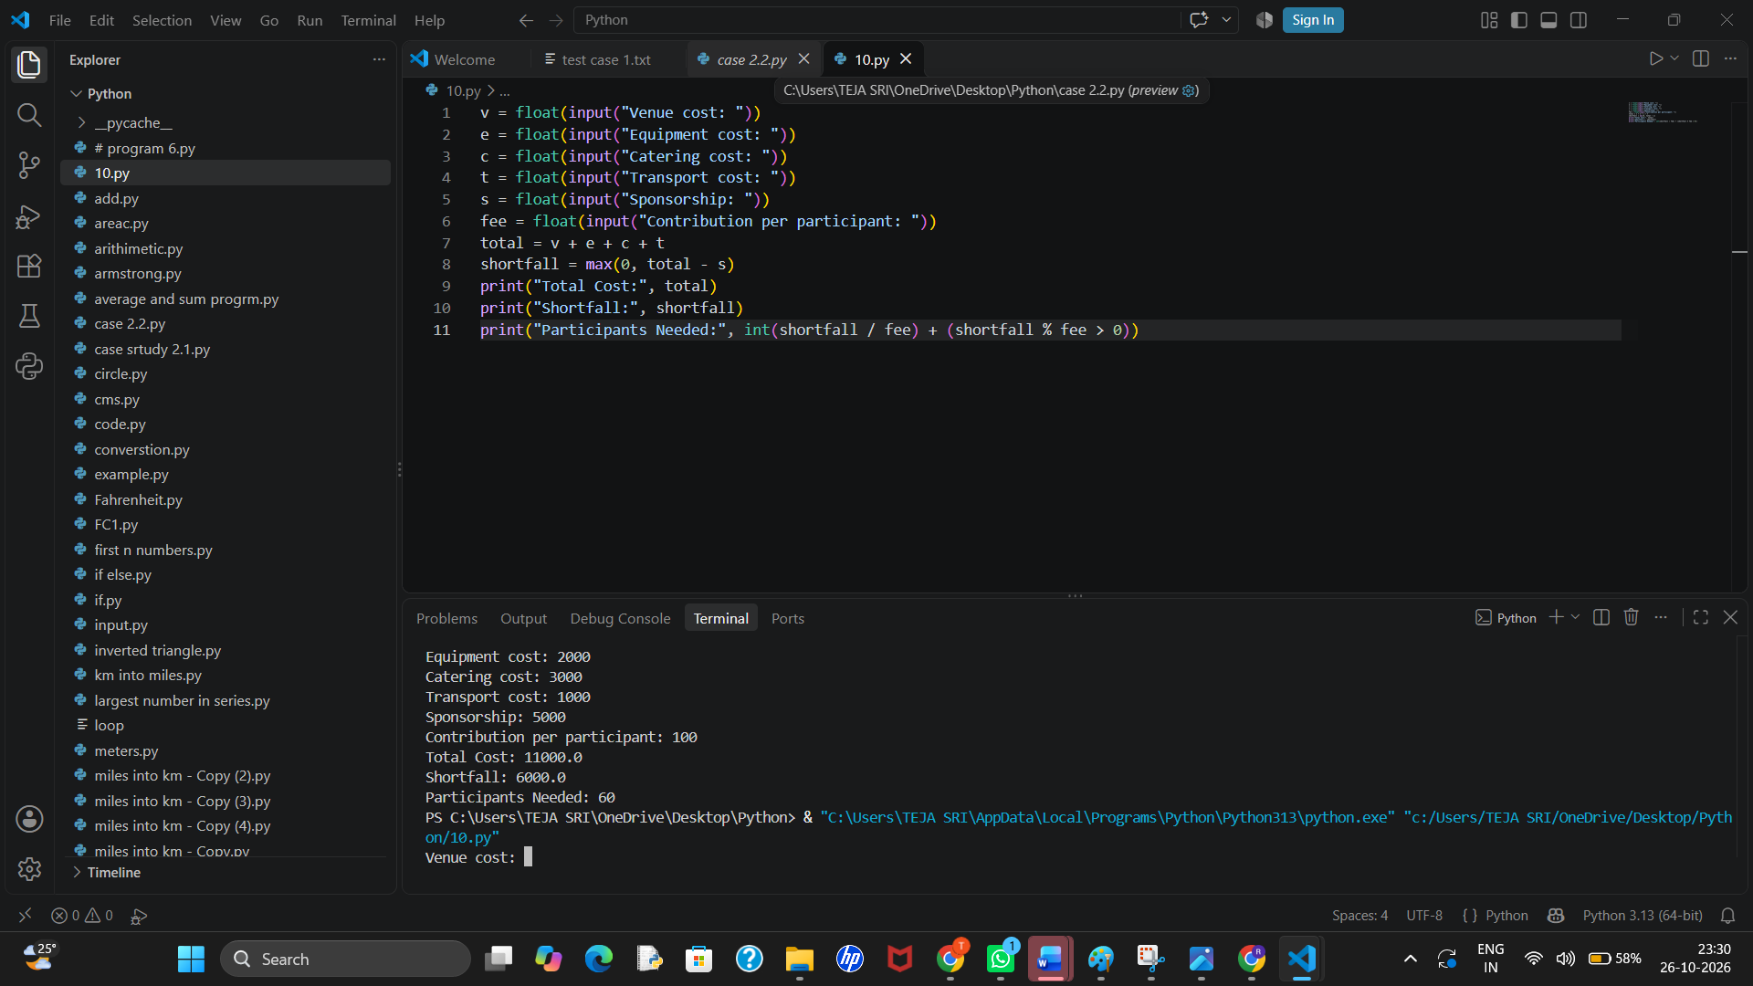

10. Conclusion
The program calculates daily and overall food waste, flags high-waste days, and provides figures that can support better meal planning.

